**CI/CD – (CONINOUS INTEGRATION/DELIVERY/DEPLOYMENT)**

**It is a Methodology. Just like sdlc**

**It is an automated process. For smooth delivery of the product.**

**And integrate and deployment the product fast.**

**There are 3 stages Build, Test, Deploy.**

**But before this there is time let’s suppose 5000 lines of code vs we test while developing fully.**

**But with ci cd we develop test and deploy not after fully developed the product.**

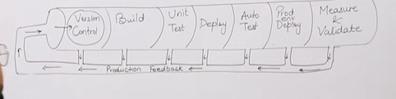

**CI/CD pipeline**

**Plan>Code>Build>Test>Deploy>Operate>Monitor**

**For 1st three git subversion is used.**

**For build there is maven or gradile but maven is widely used.**

**For test purpose selenium or JUnit**

**For deploy and operate chef puppet is used**

**And last for monitor Nagios is used**

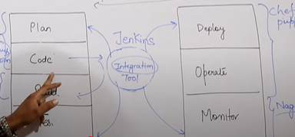

**Bamboo travis ci buildbot are other tool alternate of Jenkins but Jenkins is free and mostly used by industry**

**Jenkins**

**open source written in java that run on win macOS UNIX.**

**It is free community support and lots of plugin available**

**And first choice of everyone because of all reason.**

**It automates the entire software development life cycle**

**It was organically developed by sun microsystem in 2004 under the name Hudson**

**Hudson is also available in enterprise edition that give paid support but fail because Jenkins is free.**

**Jenkins works on master slave architecture.**

**The project was late named Jenkins when oracle bought microsystem**

**It can run on any major platform without any compatibility issue.**

**Whenever developer’s write code we integrate all that code of all developers at the point of time and we build, test and delivery/deploy to the client This process is called ci/cd**

**Jenkins helps us to achieve this.**

**Because of ci new bugs will be reported fast and get rectified fast so the entire sdlc happen fast.**

**Workflow of Jenkins**

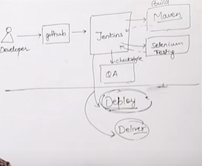

**Deliver means that we just give the product and the end user is technical known or have someone so they just setup on her own or by someone.**

**But in Deliver we give full knowledge from setup to how to use and send our team for that purpose**

**The line above process is called ci and below the line is cd**

**We can attach get, maven, selenium and artifactory plugin to Jenkins**

**Once developer put the code in GitHub, Jenkins pull that code send to maven for build**

**Once build is done, Jenkins pull that code and send to selenium for testing,**

**One testing is done, then Jenkins will pull that code and send to artifactory as per requirement and so on**

**We can also deploy with Jenkins**

**Advantages of Jenkins:**

**It has lot of plugin**

**You can write your own plugin**

**You can use community plugin**

**Jenkins is not just a tool i.e. you can do whatever you want you need is plugin**

**We can attach slaves(nodes) to Jenkins master it instruct other slaves to do job. If slaves are not available Jenkins itself does the job.**

**Jenkins also behave as crone server replacement that is scheduled in the task.**

**It can create lables.**

**Lecture 37**